8.3 Endothermic reactions absorb energy from the surroundings. Exothermic reactions release energy

Student worksheet answers (pages 160–161)

Exothermic and endothermic reactions

1 What is an exothermic reaction?

a chemical reaction that releases energy in the form of heat and light

2 What does exothermic mean?

*exo* means ‘to give out’, *thermic* means ‘heat’

3 Explain the amount of energy in reactants and products in an exothermic reaction. Draw a graph to help you.

Reactants have more energy than products. Therefore energy is released when reactants form products.

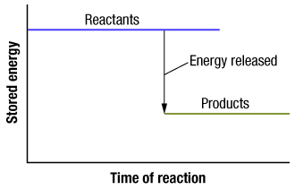

4 What is an endothermic reaction?

Energy is taken from the surroundings, causing the temperature to decrease.

5 What does endothermic mean?

By rule of opposites: *endo* means ‘to take in’ or ‘enter’, *thermic* means ‘heat’

6 Explain the amount of energy in reactants and products in an endothermic reaction. Draw a graph to help you.

Products have more energy than reactants. Therefore energy is absorbed when reactants form products.

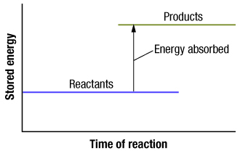

7 Give an example of an exothermic reaction and how it is used in the real world.

Sodium acetate forms crystals and produces heat (exothermic). This is used in heat packs.

8 Give an example of an endothermic reaction and how it is used in the real world.

Ammonium nitrate dissolves in water and absorbs energy as it does so (endothermic). This is used in cold packs.

EXTEND YOUR UNDERSTANDING

Hydrogen (H2) and oxygen (O2) have 0kJ of energy. In order to break their bonds and form water, 1370kJ of energy is required. Once these bonds have been broken, them atoms rearrange to form water wich contains -572kJ of energy.

9 On the graph below, draw the process of hydrogen (H2) and oxygen (O2) breaking their bonds to form water.

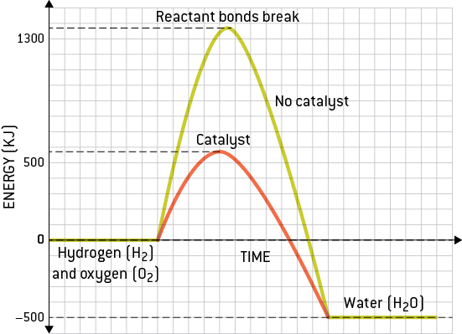

10 Catalysts are used to help a chemical reaction to occur faster. After introducing a catalyst, the energy required to break the bonds of hydrogen (H2) and oxygen (O2) lowers from 1370kJ to 500kJ. On the graph you drew above, draw a second process of hydrogen (H2) and oxygen (O2) forming water with a catalyst.